The Della and Easter Series

Motivation:
My granddaughter, Della, lives in the UK. When she was 3 years old the family came to South Africa over the Easter period. I gave her a fluffy Easter bunny for her Easter present.
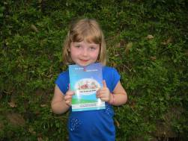
On her last day she asked me to write to her. I was confused about how I could write to a three year old! Stories seemed to be the best way and so the Easter series was born.
The author and the original illustrator met while teaching at the same high school. Tanja teaches art. When she read the Easter stories she agreed to do the illustrations. Job restrictions intervened and I had to find a new illustrator. Manuela Cardiga was a student of mine many years ago. She lives in Portugal now. I e-mail my material to her and she e-mails the completed drawings. Her interpretations are incredible and add a wealth to the stories.

The Motivator with the original book!
Della (now 5) came over on holiday and was delighted to get her very own copy of her book!

How Easter met Della
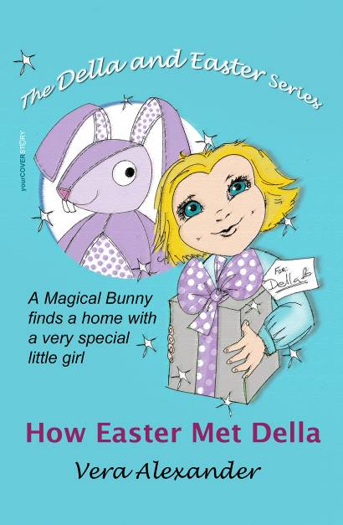 | The Easter Bunny visits a toy maker and asks him to make Easter bunnies. The toymaker has just enough material left to make a magical bunny for a special girl. Many horrible children try to buy him for nasty reasons but he does eventually find the special girl.
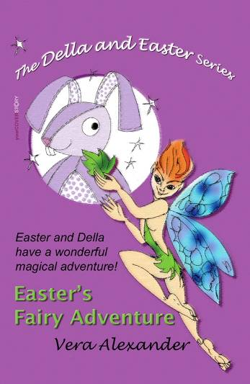 | When Della and Easter arrive at the fairy garden they can both feel the magic. Easter gets bored when Della takes a nap and joins some real bunnies for some fun and games. The fairy magic helps him when he finds that he is lost.
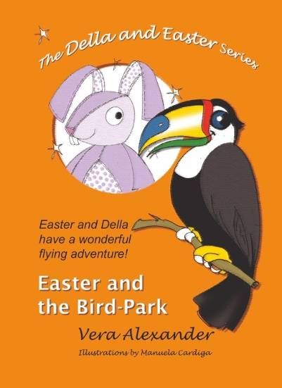 | Della's class goes on an outing to a bird park. Easter comes with and has a flying adventure. When Della's class is rewarded by a visit to the Bird Park, the children are allowed to bring a toy with as a special treat. As usual Easter lands in trouble and meets Freddie the Falcon. This is the first time that Freddie the Falcon meets Easter. They get on well and Freddie is destined to become a friend of Easter and to take a leading part in some of Easter's adventures. Easter has dreamt of flying and Freddie does his best to make this wish come true.
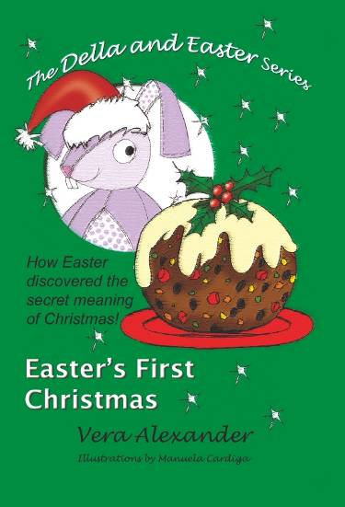 | Easter becomes aware of the word Christmas but doesn't know what it is all about. Easter is an Easter Bunny and does not understand or like the idea that Christmas is also a special time. When Easter first met Della it was a special time for both of them. It was also a special time of the year. Join him on his voyage of discovery about this wonderful festival. Easter is very upset when he feels that he is no longer special because Christmas seems to be a very special time of the year. He becomes very naughty and it takes an adventure with Freddie the Falcon to help him understand that there can be many special times in a year. He also learns about the true meaning of Christmas and shares a wonderful time with Della.

